ELECTIVE 3: FULLSTACK WEB DEVELOPMENT

MIDTERM EXAMINATION

2nd Semester, Academic Year 2021-2022

Please follow the directions for each section. Note that in each section you will have some amount of choice in the questions you’ll be answering. The exam is based on a 100-point scale.

Partial credit will be given for answers that are done partially well.

Programming (75 points).

1. Requirements:

i. Create a GitHub repository under the name format: MEX_FirstName_LastName ii. See the below diagram for the web application layout.

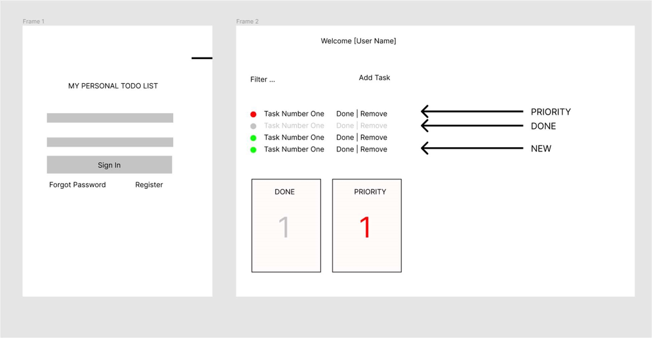 iii. It must have a login page (Hardcoded password and username is allowed).

1. It should display the name of the username in the second page.
2. It should only accept username “admin”.
3. It should only accept the password “admin1234”.
4. It should be able to to add a task with prioritization (UI is not included so you guys can design what you want here)
5. A mini dashboard below w/c displays number of DONE and PRIORITIES

(regardless of if DONE or NOT) ix. A color coding is good to differentiate tasks (RED = priority, GREEN = normal,

GRAY = done)

1. It can be filter by using the color codes above. You will have to make your own implementation of this.
2. Register and Forgot Password should take user to an ERROR 404 page.

Essay (25 points):

1. What is the difference of state and props.

Properties are a type of data that can be passed from one component to another. Props are read-only and immutable and cannot be changed. On the other hand, the state of an application represents aspects that can change. Every component has its own state. The state is mutable and only exists within the component. When working data in your computer you can see the difference in use of props and state. Props are immutable and can be used to pass data down from your view-controller and have better performance. While the State is mutable, should be manage in the view-controller, actually has worse performance, and one last thing is it should not be accessed from child components and only by passing it down with props instead.

|  |  |  |  |  |
| --- | --- | --- | --- | --- |
| Prepared By:      NINO FRANCISCO ALAMO  Professor /Instructor | Reviewed By:      REGIE ELLANA  CCS Dean | Approved By:      DR. LEAH DIGO  VP for Academic Affairs | |  |
|  |  |  | LOA-OAA-TOS-028 | |
| 10-02-2020 | REV. 00 | |

# CODE ELEC323 TITLE EXAM TERM/AY

PRELIMINARY EXAMINATION

2

ND

SEMESTER, ACADEMIC YEAR 2020-2021

ELECTIVE 3: FULLSTACK DEVELOPMENT

|  |  |  |  |  |  |  |  |  |
| --- | --- | --- | --- | --- | --- | --- | --- | --- |
| Topic # | Objectives | Remember | Understand | Apply | Analyze | Evaluate | Create | Total # of  Items/points |
| 1 | o Familiarization with React JS | 2 | 2 | 2 | 1 | 1 | 2 | 10 |
|  | Total # of items/Points | 2 | 2 | 2 | 1 | 1 | 2 | 10 |

|  |  |  |
| --- | --- | --- |
| Prepared By:      NINO FRANCISCO ALAMO  Professor /Instructor | Reviewed By:      REGIE ELLANA  CCS Dean | Approved By:      DR. LEAH DIGO  VP for Academic Affairs |